|  |  |
| --- | --- |
| **Item No:** 2.10 |  |
| **Title:** Planning Proposal RZ/38/2013 for land at Glenworth Valley and Calga |  |
| **Department:** Environment and Planning |  |
| 22 March 2022 Ordinary Council Meeting |  |

Reference: F2020/00039 - D15024570

Author: Bruce Ronan, Strategic Planner

Scott Duncan, Section Manager Land Use and Policy

Manager: Shannon Turkington, Unit Manager Strategic Planning

Executive: David Milliken, Director Environment and Planning (Acting)

**Recommendation**

1. ***That Council endorse the Planning Proposal for land at Glenworth Valley and Calga, subject to the amendments outlined in this report.***
2. ***That Council request the Chief Executive Officer to exercise delegation issued by the Department of Planning and Environment for RZ/38/2013 and proceed with the steps for drafting and making of the amendment to Gosford Local Environmental Plan 2014 or Central Coast Local Environmental Plan, whichever is in effect at the time.***
3. ***That all those who made submissions during public exhibition be notified of Council’s decision.***

|  |
| --- |
| **Report purpose**  To consider the Planning Proposal on land at Glenworth Valley and Calga following public exhibition, and seek endorsement for the Planning Proposal through an amendment to the Gosford Local Environmental Plan 2014 or Central Coast Local Environmental Plan, whichever is in effect at the time  **Executive Summary**  The Planning Proposal seeks to enable various additional permitted uses on certain land operating as *Glenworth Valley Outdoor Adventures*. The additional permitted uses will facilitate long term certainty as to the continued and future operations of *Glenworth Valley Outdoor Adventures* and permit a range of recreational and tourist related activities, whilst protecting the environmental quality of the site.  The existing zones applying to the subject land (i.e. C2 Environmental Conservation and RU2 Rural Landscape) are not being changed as part of the Planning Proposal.  The Planning Proposal underwent State agency consultation and was publicly exhibited from 22 November 2021 to 20 December 2021. Details of the feedback received and the outcome of consultation are contained in this report.  Based on community and State government agency consultation, and Council staff assessment it is recommended that Council endorse the Planning Proposal, subject to amendments outlined in this report, and that an amendment to the Gosford Local Environmental Plan 2014 or the future Central Coast Local Environmental Plan, whichever is in effect at the time, is made. |

**Background**

The Planning Proposal seeks to provide certainty for the continuation of existing uses on the subject site and to provide opportunities for additional recreation and tourist related developments in the future by adding specific additional permitted uses which can be conducted on the property.

The original Planning Proposal was supported by the former Gosford City Council on 17 December 2013 and 10 June 2014.

The Planning Proposal was subject to a Gateway Determination issued on 17 July 2014 by the Department of Planning and Environment and a subsequent Gateway extension which lapsed on 24 October 2018.

On 24 April 2018 an amended Planning Proposal was lodged.

Council considered the amended Planning Proposal on 11 November 2019 and resolved:

*1085/19 That Council defer consideration of this item for a site inspection to be*

*conducted and a briefing at the monthly planning workshop to be provided.*

Council considered the amended Planning Proposal on 27 April 2020 and resolved:

*295/20 That the Council support an amended Planning Proposal applying to:*

*- Lots 19, 20, 21, 23, 24, 25, 30, 31, 32, 33, 37, 50, 53, 64, 65, 68, 81, 82, 85, 86, 87, 89, 91, 108, 145 DP 755221,*

*- Lots 22, 23, 32, 73, 75, 76 DP 755253,*

*- Lots 1, 3 DP 617088,*

*- Lot 881 DP 563889,*

*- Lot 1 DP 1222754,*

*- Lot 7 DP 1230083,*

*- Lot 245 DP 48817,*

*- Lot 7012 DP 1059767,*

*- Lot 7029 DP 93603,*

*- Lot 7035 DP 1051932,*

*- Lot 7036 DP 1059768,*

*- Lot 7303 DP 1154929, Glenworth Valley, and*

*- Lot A DP 365595,*

*- Lot C DP 382358,*

*- Lot 2 DP 1139242,*

*- Lot 882 DP 563889,*

*- part of Lot 102 DP 1139060,*

*- Lot 7039 DP 1059766,*

*- Lot 7303 DP 1161109, Calga*

*to amend the Gosford Local Environmental Plan 2014 (or draft Central Coast Local Environmental Plan), whichever is in effect at the time, to permit the following additional permitted uses (if they are not included in the Central Coast Local Environmental Plan):*

*a on land zoned E2 Environmental Conservation, development for the purpose of eco-tourist facilities and recreation facilities (outdoor);*

*b on land zoned RU2 Rural Landscape, development for the purposes of eco-tourist facilities, camping grounds and tourist and visitor accommodation;*

*c on the existing cleared areas of the land zoned E2 Environmental Conservation, comprising Lots 19, 20, 21, 23, 25, 30, 32, 33, 37, 50, 53, 64, 68, 85, 86, 87, 89, 91, 108 and 145 DP 755221, Lots 22 and 32 DP 755253, Lot 3 DP 617088, Lot 245 DP 48817, Lot 7039 DP 1059766 and Lot 7303 DP 1154929, development for the purpose of extensive agriculture.*

*d on land comprising that part of Lot 89 DP 755221 which currently accommodates the multi-purpose building and its curtilage,*

*(i) development for the purpose of function centre, entertainment facility and food and drink premises, and*

*(ii) the total floor area for the function centre, entertainment facility and food and drink premises is to be a maximum of 1500m2 with any additions being attached to, or directly adjacent to, the existing building.*

*e on the existing cleared areas of the land zoned E2 Environmental Conservation comprising part of Lots 19, 37 and 89 DP 755221 and Lots 22 and 32 DP 755253, development for the purpose of function centre and camping ground.*

*f on the existing cleared areas of the land zoned E2 Environmental Conservation comprising part of Lots 108 and 145 DP 755221, development for the purpose of tourist and visitor accommodation.*

*296/20 That Council submit a revised Planning Proposal to the Minister for Planning in accordance with Section 3.35(2) of the Environmental Planning and Assessment Act 1979, requesting an amended Gateway Determination pursuant to Section 3.34 of the Environmental Planning and Assessment Act 1979.*

*297/20 That Council request delegation for Council to finalise and make the draft Local Environmental Plan, pursuant to Section 3.36 of the Environmental Planning and Assessment Act 1979.*

*298/20 That Council undertake community and public authority consultation, in accordance with the Gateway Determination requirements.*

*299/20 That the Council consider a further report on results of the agency and community consultation.*

In regards to Resolution 296/20, the Department of Planning and Environment (DPE) issued a Gateway Determination on 6 August 2020, which lapsed on 6 February 2022. As the Planning Proposal has been on public exhibition prior to 6 February 2022, DPE have agreed that finalisation of the Planning Proposal can occur after this date.

This report responds to the above resolutions and provides details of the outcome of the Planning Proposal following public exhibition. The Planning Proposal is currently at the stage in the Local Environmental Plan Amendment Process shown in Diagram 1.

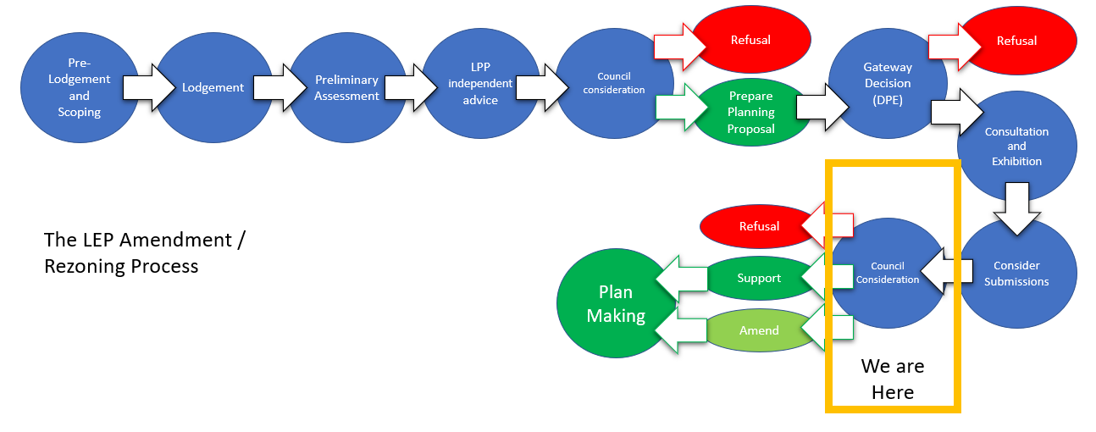***Diagram 1 –*** *Local Environmental Plan Amendment/Rezoning Process*

**Report**

*The Site* -The subject site comprises 49 lots with a total area of 1173.6 Ha.

The land represents a significant holding of environmentally important land being relatively isolated, with limited access from Cooks Road, and characterised by a cleared valley floor with vegetated hillsides and ridgelines (Figure 1).

The land comprises of a number of discrete pockets of Endangered Ecological Communities (EEC) and regionally significant vegetation throughout the site. It is located between developed agricultural and resource lands situated along Peats Ridge Road to the east and Popran National Park to the west. Popran Creek, and a number of other small watercourses which run into it, flow through the site, which then drains to the Hawkesbury River.

The land is also an established tourist destination. Its close proximity to Sydney makes it a desirable destination for a wide tourism market, including international visitors. The broad range of nature-based activities offered at the site also make it appealing for a variety of users and maximises opportunities that the site presents. Some uses are temporary (e.g. camping, outdoor recreation), whilst other uses are of a more permanent nature with some fixed structures (e.g. multi-purpose building). Different parts of the site are used for various activities (e.g. abseiling, horse riding, quad bike riding). The cleared valley floor is used for the grazing of horses and livestock.

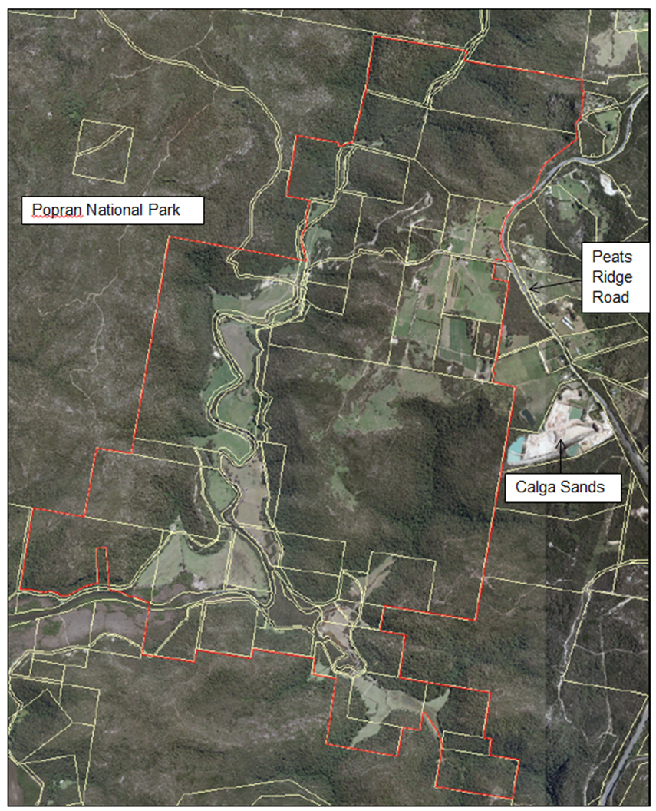

***Figure 1 –*** *Locality Map*

The subject site comprises approximately 1070.2 Ha of land zoned C2 Environmental Conservation (prior to 1 December 2021 - E2 Environmental Conservation) and 103.4 Ha of land zoned RU2 Rural Landscape under Gosford Local Environmental Plan 2014 (GLEP 2014) (Figure 2).

The zone boundaries are not proposed to be changed under the Central Coast Local Environmental Plan (CCLEP).

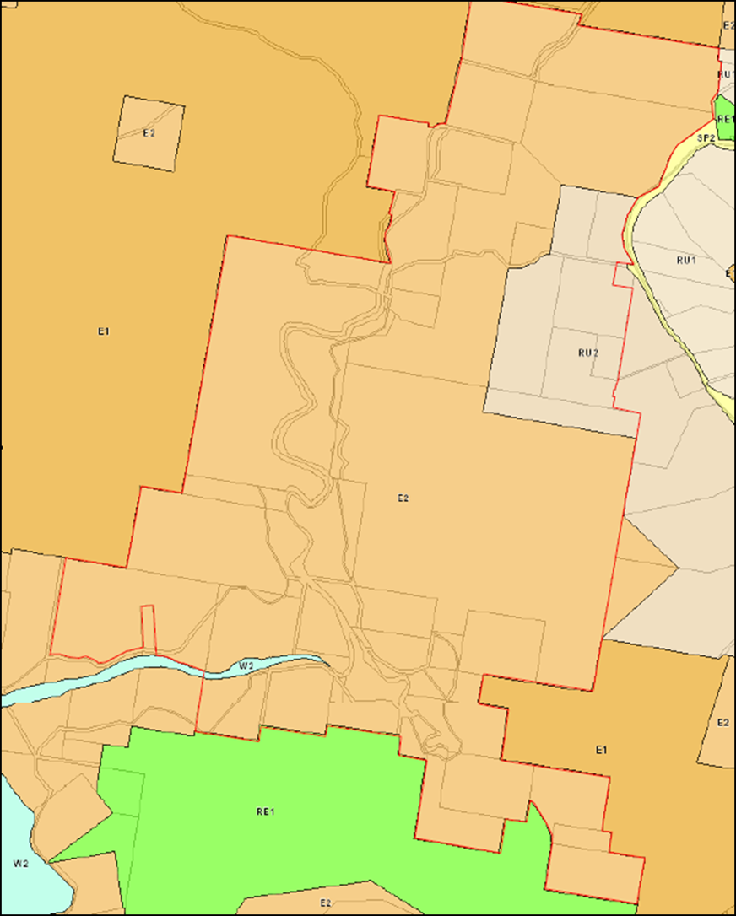

***Figure 2 –*** *Existing Zoning under GLEP 2014*

*The* Proposal- The objective of this Planning Proposal is to enable additional permitted uses on the subject land. In summary this entails:

* On land zoned RU2 Rural Landscape, the additional permitted uses of eco-tourist facilities, camping grounds, tourist and visitor accommodation;
* On land zoned C2 Environmental Conservation, the additional permitted uses of eco-tourist facilities and recreation facilities (outdoor).
* On existing cleared areas of land zoned C2 Environmental Conservation, comprising part of Lots 19, 20, 21, 23, 25, 30, 32, 33, 37, 50, 53, 64, 68, 85, 86, 87, 89, 91, 108 and 145 DP 755221, part of Lots 22 and 32 DP 755253 part of Lot 3 DP 617088, part of Lot 245 DP 48817 and part of Lot 7303 DP 1154929, development for the purpose of extensive agriculture.
* On existing cleared areas of land zoned C2 Environmental Conservation, comprising part of Lots 19, 37 and 89 DP 755221 and part of Lots 22 and 32 DP 755253, development for the purposes of camping grounds and function centres.
* On existing cleared areas of Lot 108 DP 755221 and Lot 145 DP 755221, development for the purposes of tourist and visitor accommodation.
* On land comprising part of Lot 89 DP 755221 which currently accommodates the multi-purpose building:
  + Development for the purposes of function centre, entertainment facility and food and drink premises, and
  + The total floor area for the function centre, entertainment facility and food and drink premises, is to be a maximum of 1500m2 with any additions being attached to, or directly adjacent to the existing building.

To implement these changes an amendment to Schedule 1 Additional Permitted Uses in the GLEP 2014 or CCLEP, whichever is in effect at the time, will be required. The proposed wording of the new clause in Schedule 1 will be (subject to DPE approval):

*XX Use of certain land at Calga and Glenworth Valley*

(1) This clause applies to 49 lots at Calga and Glenworth Valley identified as “Popran Creek” on the Additional Permitted Uses Map.

(2) The following development is permitted with development consent:

(i) In Area A - eco-tourist facility and recreation facility (outdoor);

(ii) In Area B - eco-tourist facility, camping ground, tourist and visitor accommodation;

(iii) In Area C - eco-tourist facility, recreation facility (outdoor), extensive agriculture;

(iv) In Area D - eco-tourist facility, recreation facility (outdoor), extensive agriculture, camping ground, function centre;

(v) In Area E - eco-tourist facility, recreation facility (outdoor), extensive agriculture, tourist and visitor accommodation;

(vi) In Area F - eco-tourist facility, recreation facility (outdoor), extensive agriculture, camping ground, function centre, entertainment facility, food and drink premises.

(3) In Area F the total floor space to be used for a function centre, entertainment facility and a food and drink premises is to not exceed 1500m2 and any additions being attached to, or directly adjacent to the existing building.

(4) Prior to any development approval being issued consultation is to occur with the respective public authorities in relation to bushfire and flooding with appropriate consideration being given to the evacuation of the site in a bushfire or flood emergency.

The accompanying Additional Permitted Uses (APU) Map pictorially indicating the subject Areas is shown in Attachment 1.

Note: - should the CCLEP be in effect when this Planning Proposal is finalised the following changes would be required:

* As “eco-tourist facilities” is a land use proposed to be permitted generally in the C2 Environmental Conservation zone, it would not be required to be included as an additional permitted use in Areas A, C, D, E and F.
* As “camping grounds” is a land use proposed to be permitted generally in the RU2 Rural Landscape zone, it would not be required to be included as an additional permitted use in Area B.

*Assessment*

The Planning Proposal for additional permitted uses on the site has strategic merit on the basis that:

* It will facilitate long term certainty as to the continued and future operations of *Glenworth Valley Outdoor Adventures* to permit a range of recreational and tourist related activities, whilst protecting the environmental quality of the site.
* The retention of existing zones with the proposed additional permitted uses will allow for the on-going development and enhancement of a significant tourist facility and ensure it remains intrinsically linked to the protection and management of the environment and allowing development at an appropriate scale.
* It will allow a regionally significant nature-based tourist development to add complementary nature-based tourist facilities, including accommodation that will build on existing capital investment, and allow additional outdoor recreational opportunities as they emerge.
* The proposed additional permitted uses are mainly located within the cleared areas of the site which will protect the environmental value of the land whilst enabling economic development of tourist related uses.

*Statutory Compliance and Strategic Justification*

The Planning Proposal has been assessed having regard for all State Environmental Planning Policies, Ministerial Directions and the relevant guidelines set out within the Central Coast Regional Plan 2036 (CCRP). The proposal is considered to be consistent with the actions related to environmental land and tourism outlined in the CRRP and the Interim Local Strategic Planning Statement (LSPS) and is therefore suitable for forwarding to the DPE for finalisation.

**Delegation**

Council has been issued with the delegations of the Minister to make amending Local Environmental Plans (LEPs). The Gateway Determination issued on 6 August 2020 provides Council the appropriate delegations under Section 3.36(2) of the *Environmental Planning and Assessment Act, 1979* to make this amendment to the LEP. Council’s delegate for this function is the Chief Executive Officer, David Farmer.

**Consultation**

The Planning Proposal was publicly exhibited from 22 November 2021 to 20 December 2021 and was undertaken in accordance with the DPE’s *A Guide to Preparing Local Environmental Plans* and the Gateway Determination.

*Community Consultation*

Two submissions were received during the exhibition period. The matters raised in the submissions are summarised and responded to in Attachment 2.

The main concerns raised are that the Planning Proposal will allow the removal of native vegetation which will negatively alter the scenic quality of the area, reduce habitat, increase traffic on local and internal roads and put pressure on adjoining conservation lands.

*Agency Consultation*

The Gateway Determination specified which agencies were to be consulted in the Planning Proposal process. The agencies were consulted prior to public exhibition and again during the exhibition period. The issues are summarised ~~i~~n Attachment 3.

As a result of Agency consultation during the exhibition period, the following amendments have been made to the Planning Proposal:

* + The Additional Permitted Uses Map has been amended to remove the biodiversity offset for the adjoining Calga Quarry. This biodiversity offset is a triangular area of 41 Ha in an isolated location in the south-eastern corner of the subject land (Lot 108 DP 755221 and part of Lot 23 DP 755221).
  + The proposed clause in Schedule 1 Additional Permitted Uses has been amended to ensure emergency responses to flooding and bushfire will be addressed with any future development proposal.

*Internal Consultation*

Internal consultation has been undertaken, as summarised below.

* Environmental Planning – most of the proposed Additional Permitted Uses are to be located within the existing cleared areas of the site so that habitat, threatened species, populations and ecological communities will not be adversely affected. Any development applications for uses within an existing vegetated area can be assessed at that time and environmental management conditions linked to the specific activity to ensure environmental values are not adversely affected.
* Waste Management – on balance it is considered that any likely increases in usage of the facilities as result of the planning proposal can be accommodated by the existing system, provided that management system are put in place. In the event that there is a more substantial increase in the daily hydraulic loadings than anticipated it has been demonstrated that the system can be modified to accommodate it. Accordingly, there are no objections to the Planning Proposal from the Environmental Health (OSSM) team.
* Flooding and Drainage – the impacts of overland flooding from upstream tributaries in the locality may impact on future structures. The assessment of such impacts would be subject to development applications and any flooding issues could be dealt with at that stage.
* Environment and Health – from a contamination perspective the Planning Proposal is suitable based on the Health Investigation Levels (HIL) C assessment criteria.
* Transport Planning – the road network has the capacity to support the various recreational and festival events being held with access to Cooks Road and its intersection with Peats Ridge Road. These roads in this remote location could be upgraded with improved parking and upgraded pedestrian access to support larger scale events or more frequent activities if desired, when future development applications are lodged. If any one-off traffic generating events occur on site, Council’s Traffic Officer and a Police Officer liaise with the applicant and oversee the implementation and monitoring of temporary Traffic Management Plans (TMPs) to address such issues as queuing along Peats Ridge Road. No objection is raised to the independent use of the existing multi-purpose building or other activities provided any development proposals are assessed in accordance with the RMS Guidelines for Traffic Generating Development.

*Outcomes of Consultation*

Based on the community and State government agency feedback, the Planning Proposal has satisfied relevant statutory requirements relating to consultation.

**Link to Community Strategic Plan**

Theme 2: Smart

|  |
| --- |
| **Goal C: A growing and competitive region** |
| S-C4: Promote and grow tourism that celebrates the natural and cultural assets of the Central Coast in a way that is accessible, sustainable and eco-friendly. |

Theme 3: Green

|  |
| --- |
| **Goal F: Cherished and protected natural beauty** |
| G-F1: Protect our rich environmental heritage by conserving beaches, waterways, bushland, wildlife corridors and inland areas, and the diversity of local native species. |

Theme 5: Liveable

|  |
| --- |
| **Goal L: Healthy lifestyle for a growing community** |
| L-L1: Promote healthy living and ensure sport, leisure, recreation and aquatic facilities and open spaces are well maintained and activated. |

**Financial Considerations**

At its meeting held 19 October 2020, Council resolved the following:

*1108/20 That any motions put before Council for the remainder of this term of Council that have financial implications require the Chief Executive Officer to provide a report on how those additional costs will be met.*

The recommendations have no financial implications for Council. The direct cost to Council is the preparation of the Planning Proposal, which will be charged as per Council’s Fees and Charges, on a cost recovery basis.

**Risk Management**

Any matters that have identified through assessment have been addressed. There are no risks identified to the natural and built environment if this Planning Proposal is endorsed by Council.

**Options**

1 Endorse the Planning Proposal. The Planning Proposal has strategic merit and any matters raised during public exhibition or through agency consultation have been addressed. **This is the recommended option.**

2 Refuse the finalisation of the Planning Proposal. The Planning Proposal has been assessed on its merit and is deemed to be a suitable proposal. In Council staff opinion there is no reason why it should be refused. Not recommended.

**Attachments**

|  |  |  |  |
| --- | --- | --- | --- |
| **1** | APU Map for Glenworth Valley and Calga | Provided Under Separate Cover | D15039652 |
| **2** | Community Consultation | Provided Under Separate Cover | D15080157 |
| **3** | Agency Consultation | Provided Under Separate Cover | D15080162 |